
ResQFood: A Community-Based Surplus Food Redistribution and Monitoring Platform

A Capstone Project Presented to the Faculty of the College of Computer Studies
University of Southern Philippines Foundation
Salinas Drive, Lahug, Cebu City, Cebu

In Partial Fulfillment of the Requirements for the
Degree of Bachelor of Science in
Information Technology

John Rubi E. Recanil
Jossiah Iverson
2027

List of Tables

Table of Contents

List of Tables i
List of Figures ii
Table of Contents iii
CHAPTER 1 1
Introduction 1
Background of the Study 1
Statement of the Problem 2
Objectives of the Study 2
Significance of the Study 3
Scope and Limitations 3
Definition of Terms 4
CHAPTER 2 12
Review of Related Literatures and Studies
REFERENCES

CHAPTER 1

INTRODUCTION

Background of the Study

Food waste remains a significant global issue that affects both environmental sustainability and food security. Large amounts of edible food are discarded daily by households, restaurants, and markets due to overproduction, improper distribution, and lack of coordination. At the same time, many communities continue to experience food insecurity, where individuals lack access to sufficient and nutritious food.

According to the Food and Agriculture Organization (FAO), approximately one-third of all food produced globally is wasted each year [1]. This highlights a critical inefficiency in food systems, where surplus food is not effectively redistributed to those in need. Studies also emphasize that reducing food waste is essential for achieving sustainable food systems and improving resource utilization [3].

In line with the United Nations Sustainable Development Goals (SDGs), particularly SDG 2: Zero Hunger, addressing food waste is a key strategy in ensuring food availability and accessibility [2]. Additionally, food rescue initiatives demonstrate that surplus food can be redistributed effectively when proper systems and coordination are in place [4].

However, many existing food donation practices rely on manual and fragmented methods such as phone calls and social media, resulting in delays, miscommunication, and lack of transparency. These limitations highlight the need for a centralized and technology-driven solution.

To address these challenges, this study proposes ResQFood: a Community-Based Surplus Food Redistribution and Monitoring System, developed as a Progressive Web Application (PWA). A PWA combines the accessibility of web applications with the functionality of mobile applications, enabling users to access the system across devices, receive real-time notifications, and operate efficiently even with limited resources [6].

ResQFood integrates key features such as surplus food reporting, volunteer coordination, real-time notifications, QR code-based tracking, and an administrative monitoring dashboard. The use of QR code technology allows accurate tracking of food donations from donors to beneficiaries, ensuring transparency and accountability throughout the process.

The primary goal of this project is to transform traditional food donation practices into a more efficient, organized, and data-driven system. By leveraging digital technologies, the system aims to improve coordination, reduce food waste, and enhance food accessibility within the community.

Statement of the Problem
Many communities are facing two major challenges: the increasing generation of food waste and persistent food insecurity. Despite the availability of surplus food, the lack of a structured redistribution system results in food being discarded instead of being utilized.
This study aims to address the following problems:

General Problem
How can a Progressive Web Application-based Community Food Rescue Management System improve the coordination, monitoring, and redistribution of surplus food within the community?

Specific Problems
- How can surplus food donations be efficiently reported and coordinated?
- How can effective coordination among food donors, volunteers, and organizations be achieved?
- How can food recovery and distribution processes be monitored and tracked using QR code technology?
- How can data generated from food rescue operations be utilized for reporting and planning?
Objectives of the Study

General Objective
To develop a Progressive Web Application-based Community Food Rescue Management System (ResQFood) that enhances food donation, coordination, monitoring, and tracking within the community.

Specific Objectives
- To design and develop a PWA system that enables real-time communication between donors and volunteers.
- To implement a QR code-based tracking system for monitoring food donations from donor to beneficiary.
- To develop a monitoring system that tracks food rescue operations using digital tools.
- To create an administrative dashboard for managing food donations and volunteer activities.
- To integrate a notification system that provides real-time updates.
- To evaluate the system in terms of usability, efficiency, and functionality through user testing.

Significance of the Study
This study provides meaningful contributions to various stakeholders:

Community
Helps reduce food waste and improves access to food through efficient redistribution.

Food Donors
Provides a convenient and structured platform for donating surplus food.

Volunteers and Organizations
Enhances coordination and efficiency in food rescue operations.

Local Government Units (LGUs)
Supports planning and decision-making through centralized monitoring and data analytics.

Future Researchers
Serves as a reference for future studies related to food waste management and digital systems.

Scope and Limitations

Scope
This study focuses on the design and development of a Progressive Web Application (PWA)-based Community Food Rescue Management System (ResQFood) within a selected community.
The system includes the following functionalities:
- User Registration and Management
- Food Donation Posting
- Volunteer Management
- Real-Time Notification System
- QR Code-Based Tracking System
- Monitoring Dashboard and Analytics
The system will be evaluated based on:
- Usability (ease of use and user satisfaction)
- Functionality (system performance and feature effectiveness)
- Efficiency (speed of coordination and response time)
Evaluation will be conducted through user testing, surveys, and feedback collection within a controlled environment.

Limitations

However, the following limitations of this study are worth mentioning despite its intended contributions:

- Prototype-Level System Construction
It should be noted that the system is created at the prototype level, which means that it cannot be used in a wide range of areas.
- Local Testing Area
The system is tested in a local area only, while its efficiency is determined by the involvement of users from different parts of the world.
- Internet Connection Dependence
The proposed system can operate effectively only in case of a reliable internet connection; otherwise, its features are limited.
- Volunteer Engagement
The operation of the system presupposes the engagement of donors, volunteers, and organizations, without which it will not bring desirable results.
- Constraints of Experimental Conditions
In experimental conditions, various problems related to logistics, implementation, and sustainability cannot be considered.

Definition of Terms
Food Waste – Edible food that is discarded or not consumed.
Surplus Food – Extra food that is still safe for consumption but no longer needed.
Food Rescue – The process of collecting and redistributing surplus food.
Donor – A person or organization that provides surplus food.
Volunteer – A person who assists in collecting and distributing food.
Monitoring System – A digital platform used to track food redistribution activities.
QR Code – A machine-readable code used to track food donation transactions.
Progressive Web Application (PWA) – A web-based application that functions like a mobile app, offering offline capabilities and real-time notifications [6].
Platform – A web-based system used to facilitate coordination and communication.

CHAPTER 2
REVIEW OF RELATED LITERATURE AND STUDIES
2.1 Related Literature
This section presents a review of relevant international and local literature.
International Literature
The global food waste crisis is staggering in its scale. The Food and Agriculture Organization (FAO) estimates that roughly one-third of all food produced for human consumption, approximately 1.3 billion tons, is lost or wasted annually. This immense loss is a primary driver of environmental degradation, squandering water, land, and energy resources while contributing significantly to greenhouse gas emissions. The United Nations Environment Programme's (UNEP) 2024 Food Waste Index Report brings this issue into sharper focus, quantifying that 1.05 billion tonnes of food were wasted in 2022 alone, which equates to 132 kilograms per capita at the retail and consumer levels.
Policy frameworks are critical for large-scale change. The Food Waste Hierarchy, as articulated by Papargyropoulou et al. (2014), provides an essential conceptual model, prioritizing the prevention of food waste, followed by redistribution to people in need. This principle of valuing surplus food is enacted in legislation such as the United States' Bill Emerson Good Samaritan Food Donation Act, which protects donors from liability, a common barrier to corporate food donations. Complementing these large-scale approaches, digital platforms like Sharing Excess have demonstrated that technology can bridge the logistical gap, creating efficient networks for food rescue and redistribution in various communities.
The technological capacity to support these systems has matured considerably. A Progressive Web Application (PWA) represents a significant advancement in web technology. Biørn-Hansen et al. (2017) define PWAs as a new class of web applications that aim to combine the broad reach of the web with the performance and user experience of native mobile apps through features like offline access, push notifications, and home screen installation. Studies have further confirmed their advantages over native applications, particularly for community-based systems, citing lower development costs, greater accessibility, and inherent cross-platform compatibility【10†L0-L2】. To ensure operational transparency, QR code technology offers a simple yet powerful method for tracking items. A smart QR-based shelf-life and food-sharing platform can dynamically monitor food freshness and link users to donation networks, providing a clear, auditable trail for all stakeholders.

Local Literature
In the Philippines, the dual challenge of significant food waste and widespread hunger creates a pressing need for systematic solutions. The UNEP 2024 Food Waste Index Report estimates that the country generates 2.95 million tonnes of household food waste annually, which is approximately 26 kilograms per capita. A stark illustration of this waste is that in 2024 alone, the Philippines discarded 255,000 metric tons of rice, enough to feed 2.79 million Filipinos for an entire year.
This waste persists alongside alarming levels of food insecurity. According to a Social Weather Stations (SWS) survey, involuntary hunger affected 22.9% of Filipino families in September 2024, the highest rate since the peak of the COVID-19 pandemic. This food paradox highlights a critical inefficiency in the nation's food systems, where surplus and need are not being effectively matched.
The legal framework to address this paradox exists. Republic Act No. 9803, also known as the Food Donation Act of 2009, was enacted specifically to encourage the donation of surplus food for charitable purposes and aims to reduce food wastage while alleviating national poverty. This law, along with the broader Ecological Solid Waste Management Act of 2000 (RA 9003), provides a policy basis for diverting edible food from landfills to communities in need.
Local food rescue initiatives are actively implementing these principles. The Scholars of Sustenance (SOS) Philippines, a prominent food rescue foundation, has been operating in the country since October 2022 and has successfully served over five million meals by rescuing surplus food from farms and various industries. There is also growing academic and civic focus on the topic; for example, a UI/UX design project titled "KKB (kanya-kanyang bigay)" explored the development of a food-sharing mobile application specifically to facilitate food redistribution and reduce waste in Metro Manila.

2.1 Related Studies
This section presents a review of international and local studies that inform the development of the ResQFood platform.
International Studies
Several studies have investigated the use of technology to optimize food rescue logistics. A study by Gajendra et al. (2021) provides a comparative analysis of Progressive Web Apps (PWAs) versus native applications. The research concluded that PWAs are particularly advantageous for projects with limited resources due to their cross-platform compatibility and ease of deployment, making them an ideal architectural choice for community-focused initiatives like food redistribution networks【10†L0-L2】.
Research on the practical application of tracking technology has demonstrated clear benefits. A study on a smart, QR-based food-sharing platform found that integrating QR codes, cloud storage, and mobile interfaces could dynamically track food items and effectively connect retailers with donation networks. The results highlighted improved operational efficiency and reduced manual tracking errors. This finding was corroborated by a case study of the "Share My Meals" platform, which uses QR-code-linked forms to trigger automated entries in its logistics and donor databases, creating a seamless, real-time inventory and impact tracking system.
Beyond logistical optimizations, research has validated the effectiveness of digital food donation platforms. A study on a food donation application built with the MERN stack (MongoDB, Express.js, React, Node.js) demonstrated that a web-based application could significantly streamline the donation process. The research, which involved user testing, found that the platform effectively enabled donors to log food items and set pickup times, while NGO staff could manage incoming donations and coordinate logistics with greater ease.

Local Studies
Local academic inquiry has often focused on the feasibility and design of technological solutions for food insecurity. A study conducted at the University of the Philippines (UP) Diliman explored a policy proposal to enact legislation that would channel food surpluses from retailers to those in need, highlighting an early recognition of the legal and systemic potential to combat hunger through redistribution.
Technological innovation is already being applied in this space by Philippine students. A team from the University of Santo Tomas (UST) developed a project named "Stray Surplus," which used AI to assess surplus food for safety and then connected donors with animal shelters via the Google Maps API. This project, which won an award in Singapore, demonstrates the practical viability of using a technology platform to manage and redirect surplus food, even with complex routing and assessment requirements.
The human dimension of food redistribution has also been the subject of empirical research. A study on the Rapid Emergencies and Disasters Intervention (REDI) program in the Philippines used a realist evaluation approach to examine how a network of volunteer religious leaders addressed emergency food insecurity during the COVID-19 pandemic. The study’s findings emphasized that a trusted network of volunteers is the critical component for the effective last-mile delivery of food aid, proving that technology must be purpose-built to support and coordinate, not replace, human compassion.

2.3 Synthesis of the Review
The reviewed international and local literature and studies collectively confirm that food waste and food insecurity are parallel crises that require systemic, technology-driven intervention. Globally, as much as one-third of food is wasted, a reality mirrored in the Philippines, where 2.95 million tonnes of household food waste are generated annually alongside a hunger rate that affected nearly 23% of families in late 2024. The Food Waste Hierarchy and legislative frameworks like the Philippine Food Donation Act of 2009 (RA 9803) both underscore that surplus food should be redirected to people, yet in practice the connection between surplus and need remains inefficient.
The literature highlights that Progressive Web Applications (PWAs) offer a viable architectural solution for community-focused systems, combining the reach of the web with native-like features including offline access and push notifications. International studies confirm that PWAs can reduce development costs and improve accessibility, while local academic and civic projects – from UP Diliman policy proposals to the “Stray Surplus” AI-based platform and the “KKB” food-sharing app – show growing interest in using digital tools to bridge the food rescue gap within the Philippines.
However, a consistent theme across both international and local findings is that existing food rescue efforts still depend heavily on manual coordination, lack real-time notifications, and do not integrate tracking mechanisms such as QR codes. The local REDI program further revealed that trusted volunteer networks are the backbone of last-mile delivery, yet these networks currently operate without a unified digital platform that can assign, track, and report on their activities. Consequently, combining a PWA with QR-based tracking and a centralized dashboard emerges as a comprehensive solution: the PWA ensures broad accessibility and real-time communication, while QR codes provide transparency and accountability from donor to beneficiary. This synthesis directly shapes the design of ResQFood, which will simultaneously address the technological and human-coordination gaps identified both internationally and in the local Philippine setting.

2.4 Research Gap
While previous studies and existing systems have made important contributions, several specific gaps remain unaddressed, particularly when considering the local Philippine context:
- Absence of an Integrated, Centralized Platform
Food rescue operations – both locally (e.g., SOS Philippines) and abroad – still rely on fragmented tools such as phone calls and social media. No single platform integrates surplus food reporting, volunteer coordination, real-time tracking, and data analytics, resulting in duplicated effort and unmonitored food flows.
- Lack of Real-Time Notification and Response Mechanisms
Timely communication is critical to preventing edible food from spoiling. Despite the availability of push-notification technology in PWAs, most existing applications, including student-led projects like “KKB,” do not employ real-time alerts that can instantly notify volunteers of a nearby pickup, leading to delays and food loss.
- Limited Use of Tracking Technologies in Local Food Rescue
While QR code tracking has proven effective in international prototypes and logistics systems, there is no documented application of QR-based tracking in Philippine community food rescue programs. This gap prevents stakeholders from verifying the chain of custody, undermining transparency and donor confidence.
- Insufficient Data for Evidence-Based Planning
Current manual processes generate little to no operational data. Local government units (LGUs) and organizations lack access to metrics such as the volume of food rescued, response times, or volunteer performance. Without data dashboards, planning and resource allocation are based on intuition rather than evidence.
- Underutilization of Progressive Web Applications in the Local Food Redistribution Domain
Although PWAs have been shown to be cost-effective and cross-platform, Philippine studies on food redistribution (e.g., UST’s “Stray Surplus”) have predominantly used native or traditional web technologies. No local study has yet designed and evaluated a PWA-based food rescue management system that leverages offline capabilities, installability, and push notifications to meet the unique challenges of Philippine communities.
These gaps illustrate that the problem is not a lack of food or goodwill, but a deficit in coordination and digital infrastructure. ResQFood is designed specifically to fill these voids by providing a centralized, PWA-based platform with integrated QR tracking, real-time notifications, and an analytics dashboard tailored to the needs of Filipino donors, volunteers, and LGUs.
CHAPTER 3 METHODOLOGY
3.1 Conceptual Framework
The study follows the Input–Process–Output (IPO) Model as its conceptual framework. This model illustrates how the information provided by users is processed by the ResQFood system to produce efficient food redistribution, monitoring, and reporting outcomes, ultimately contributing to broader community impacts.
The IPO model is appropriate for this study because it clearly presents how the proposed ResQFood: Community-Based Surplus Food Redistribution and Monitoring System transforms user inputs into systematic outputs, and how those outputs, in turn, enable expected outcomes that address food waste and food insecurity.
This framework is anchored on the Food Waste Hierarchy (Papargyropoulou et al., 2014), which prioritizes the redistribution of surplus food to people in need over disposal. It also aligns with the United Nations Sustainable Development Goal SDG 2: Zero Hunger, which calls for sustainable food systems and improved food access. By operationalizing these principles, ResQFood provides a technology-driven pathway to move surplus food from donors to beneficiaries efficiently and transparently.

Conceptual Framework Diagram
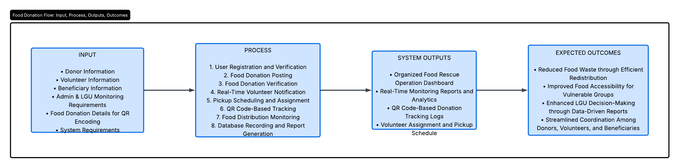
Figure 3.1: Conceptual Framework of ResQFood

Explanation of the IPO Components
Input
The Input stage includes all necessary data from donors, volunteers, beneficiaries, and administrators. Donors supply surplus food details (food type, quantity, expiration date, and pickup location). Volunteers provide their availability schedules and contact information. Beneficiary organizations submit their location and specific needs. Crucially, administrators and LGU personnel contribute their monitoring requirements – the key performance indicators and report formats they need for planning. Additionally, donation details are marked for QR encoding (a unique donation ID, timestamp, and item description) serve as system inputs that will later enable transparent tracking. System requirements, including user needs and known community food rescue challenges, also form part of the input.
Process
In the Process stage, the system performs a sequence of automated and semi-automated activities: user registration and verification, food donation posting and verification, real-time volunteer notification, pickup scheduling and assignment, QR code-based tracking of donations from pickup to delivery, food distribution monitoring, and database recording with report generation. This stage ensures smooth coordination, minimizes delays resulting from manual methods, and improves accountability through a centralized digital trail.
System Outputs and Expected Outcomes
The framework distinguishes between what the system directly produces and the broader community impacts it enables. System Outputs are the tangible products of the platform: the organized dashboard, monitoring reports, QR tracking logs, and volunteer schedule. These outputs then support Expected Outcomes such as reduced food waste, improved food accessibility for vulnerable groups, enhanced LGU decision-making through data-driven insights, and streamlined coordination among all stakeholders. This distinction demonstrates that while the software delivers the digital infrastructure, the actual reduction in waste and improvement in food access depend on sustained adoption by users.

Connection to the Statement of the Problem
This framework directly addresses the specific problems identified in Section 1.2. The Input phase captures donor and volunteer information that is currently dispersed and uncoordinated. The Process phase replaces manual phone-call and social-media coordination with real-time notifications and QR code-based tracking. The Output phase generates the monitoring data and analytical reports that LGUs and organizations have so far lacked for evidence-based planning. By integrating a Progressive Web Application with QR tracking and a centralized dashboard, the framework illustrates a systematic solution to the coordination, transparency, and data-gap challenges central to this study.

3.2 Research Design
This study uses a descriptive-developmental research design combined with a system development approach.
The descriptive method is used to identify existing problems in food donation and redistribution practices, particularly the challenges in coordination, monitoring, and reporting.
The developmental approach focuses on designing and developing the proposed web-based system, ResQFood, as a technological solution to address the identified problems.
The study also incorporates qualitative method through interviews, surveys, and usability testing to gather user requirements and evaluate system effectiveness.

3.3 Research Locale
The study will be conducted in [Barangay ________], Cebu City, Cebu. This barangay
was selected based on the following criteria: (1) presence of active community
organizations and small food establishments that regularly generate surplus food;
(2) documented participation in local food donation drives; and (3) accessibility
for the researchers during the development and testing phases.
The barangay has a population of approximately [X] residents and includes several
carinderias, bakeries, and a public market, which are typical sources of daily
surplus food. Testing within this single, well-defined locale allows the
researchers to closely monitor the system’s workflow and gather meaningful
feedback before any future scaling.

3.4 Participants
The participants of the study will be selected using purposive sampling to ensure
that all user roles of the ResQFood system are represented. The target
participants are:

- Food Donors (5–10): Owners or managers of local food establishments
(restaurants, bakeries, caterers) who regularly have surplus food.
- Volunteers (5–10): Individuals already involved in community service or willing
to participate in food rescue operations.
- Beneficiary Organizations (2–3): Representatives from local feeding programs,
orphanages, or community pantries that will receive the food.
- LGU Personnel (1–2): Barangay officials or staff who can provide insight into
current food-related programs and data needs.
- System Administrators (1–2): Individuals designated to manage the platform.

The total number of participants is expected to be between 15 and 25. This number
is sufficient for a prototype evaluation that combines qualitative feedback with
small-scale usability testing.
3.5 Data Gathering Procedures
The study will use three main research instruments:

1. Interview Guide – A semi-structured interview guide will be used during the
initial requirement gathering phase. It will cover current food donation
practices, challenges, and expectations for a digital platform. (See Appendix A.)

2. Survey Questionnaire – A structured questionnaire will be administered after
the usability testing of the prototype. The questionnaire will be divided into
three parts:
- Part A: Demographic Profile (role, frequency of donation/volunteering)
- Part B: System Usability Scale (SUS) – The standard 10-item SUS questionnaire
will be used to measure perceived usability.
- Part C: Perceived Efficiency & Functionality – Customized Likert-scale items
(1-Strongly Disagree to 5-Strongly Agree) adapted from the Technology
Acceptance Model (TAM) constructs of perceived usefulness and perceived ease
of use (Venkatesh et al., 2003).

3. Observation Checklist – During the prototype walkthrough, the researchers will
record task completion rates, time to complete each core task (e.g., posting a
donation, scanning a QR code), and any errors encountered.

3.6 Data Gathering Procedures
The data gathering will proceed in three phases:
Phase 1: Pre-Development Requirement Gathering
1. Obtain approval from the university and, if required, from the barangay office.
2. Distribute consent forms to potential participants.
3. Conduct one-on-one or small-group interviews with donors, volunteers, and LGU
personnel using the interview guide.
4. Observe existing food donation activities to document the current manual
workflow, bottlenecks, and information flow.

Phase 2: Prototype Development and Internal Testing
1. Develop the system iteratively following the Agile methodology.
2. Conduct continuous unit and integration testing during each sprint.
3. Carry out an internal walkthrough with the research team to fix critical
issues before user testing.

Phase 3: User Evaluation
1. Invite the selected participants for a hands-on testing session.
2. Brief participants on the system’s purpose and provide a set of scenario-based
tasks (e.g., “Post a surplus food donation,” “Accept a volunteer assignment,”
“Scan the QR code upon delivery”).
3. Observe and record task performance using the observation checklist.
4. Immediately after the session, administer the survey questionnaire and
conduct a short debriefing interview to gather qualitative feedback.
3.7 Data Analytics
The data analysis will employ both quantitative and qualitative methods:
- Qualitative Data from the interviews and open-ended debriefing questions will
be analyzed using thematic analysis. Responses will be coded, grouped into
themes, and triangulated with the quantitative findings to provide a
comprehensive evaluation of the system.
3.8 Research Validity
To ensure the validity and reliability of the research instruments:
- Face and Content Validity: The interview guide and survey questionnaire will be
reviewed by a panel composed of the capstone adviser and at least one IT
industry practitioner. Their feedback will be used to refine unclear or
irrelevant items.
- Construct Validity: The survey items for perceived usability and usefulness are
adapted from established TAM scales and the System Usability Scale, which have
been validated in numerous prior studies.
- Reliability: A pilot test of the questionnaire will be conducted with five
individuals who are not part of the final sample. Cronbach’s alpha will be
calculated; a value of 0.70 or higher will be considered acceptable for
internal consistency.
- Triangulation: Findings from the observation, survey, and interviews will be
compared to corroborate patterns and reduce single-method bias.

3.9 Ethical Considerations
This study strictly adheres to ethical research standards. All participation is
voluntary; respondents will be fully informed of the study’s purpose, procedures,
and their right to withdraw at any time without penalty. Written informed consent
will be obtained prior to any interview or survey. Personal information will be
anonymized and stored in password-protected files accessible only to the research
team. Data collected will be used exclusively for academic purposes. Permission
will be secured from the barangay office and, where applicable, from institutional
heads of beneficiary organizations. The researchers will also ensure that the
system demonstration does not disrupt actual food donation operations or
compromise food safety.

3.9 System Development Methodology
The study employs the Agile Software Development Methodology, specifically a
Scrum-inspired approach, for the development of ResQFood. Agile was chosen because it allows continuous improvement, iterative development, and regular feedback from stakeholders. This flexibility ensures that the system remains aligned with user needs throughout the development process.
The development will follow these five phases, which are detailed in the
subsequent sections:
1. Planning Phase
2. Analysis Phase
3. Design Phase
4. Development Phase
5. Implementation and Testing Phase

3.11 Planning Phase
During this phase, the researchers identified the project scope, objectives, and
technical feasibility. Key activities included problem identification through
stakeholder interviews, requirement gathering via surveys and observation, a
feasibility study covering technical and operational aspects, and resource
planning. A project timeline was established to guide the development, as shown
in Table 3.1.

Table 3.1: Project Development Timeline
Phase | Activities
Planning | Requirement gathering, feasibility study, resource allocation
Analysis | User requirements, use cases, DFD , non-functional requirements
Design | Interface design, database design, architecture, class diagram
Development | Coding, unit testing, integration
Testing & Evaluation | User acceptance testing, usability testing, data analysis

3.12 Analysis Phase
This phase focused on defining what the system must accomplish from the users’ perspective. The following outputs were produced.
3.12.1 User Requirements Specification (URS)
The system requires five user roles, each with distinct access levels and
responsibilities, as summarized in Table 3.2.
Table 3.2: User Requirements Specification

User Role | Main Responsibility
Food Donor | Posts surplus food details and pickup location
Volunteer | Accepts assignments, picks up and deliver food, scan QR codes
Beneficiary | Receives food and confirms delivery
Administrator | Manage users, assigns volunteers, monitor operations
LGU Personnel | Views reports and analytics for planning

3.12.2 Functional Requirements
The system must provide the functionalities listed in Table 3.3.
Table 3.3: Functional Requirements
ID | Descriptions | Priority
FR01 | Register and authenticate users | Must
FR02 | Post, edit, and delete food donations | Must
FR03 | Verify and approve food donations | Must
FR04 | Notify volunteers for pending pickups in real time | Must
FR05 | Assign volunteers to food pickups | Must
FR06 | Generate unique QR for each donation | Must
FR07 | Scan QR codes at pickup and delivery points | Must
FR08 | Track donation status from donor to benefiiciary | Must
FR09 | Generate monitoring report and analytics | Should
FR10 | Provide an admin dashboard for system management | Must

3.12.3 Use Case Diagram and Descriptions
The Use Case Diagram in Figure 3.2 illustrates the interactions between the actors
(Donor, Volunteer, Beneficiary, Admin) and the system.
User Role | Main Responsibility
Food Donor | Posts surplus food details and pickup location
Volunteer | Accepts assignments, picks up and deliver food, scan QR codes
Beneficiary | Receives food and confirms delivery
Administrator | Manage users, assigns volunteers, monitor operations
LGU Personnel | Views reports and analytics for planning
Key use case descriptions are provided below.
Table 3.4: Use Case Description – Post Food Donation
Use Case | Post Food Donation
Actor | Donor
Precondition | Donor is logged into the system
Main flow | 1. Donor selects “Donate Food”  2. System displays donation form  3. Donor fills in food details and pickup location  4. Donor submits the form  5. System validates input and saves donations  6.System sends notification to available volunteers  4a. Required field missing – system prompts the donor to complete the field
Post condition | Donation record is saved, volunteers are notified
Table 3.5: Use Case Description – Track Donation via QR Code
Use Case | Track Donation via QR Code
Actor | Volunteer
Precondition | Volunteer has accepted a pickup assignment
Main flow | !. Volunteer arrives at pickup location  2. Volunteer scans donation QR code-based  3. System logs pickup timestamp  4. Volunteer delivers food to beneficiary  5. Volunteer scans QR code again at delivery  6. System logs delivery timestamp and marks donation as completed  5a. QR code unreadable – volunteer manually enters donation code
Post condition | Donation status updated to “Delivered”

3.12.4 Data Flow Diagram (DFD)
A Context Diagram (Level 0 DFD) and a Level 1 DFD were created to model the
system’s data flows.
Context Diagram – Figure 3.3
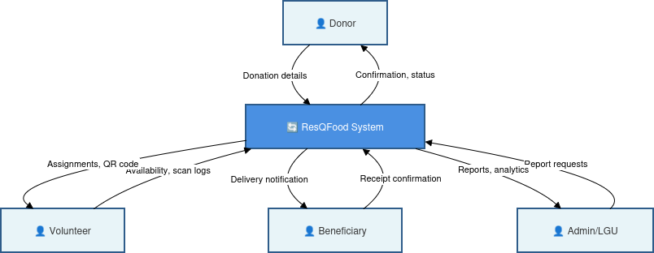

Level 1 DFD – Figure 3.4

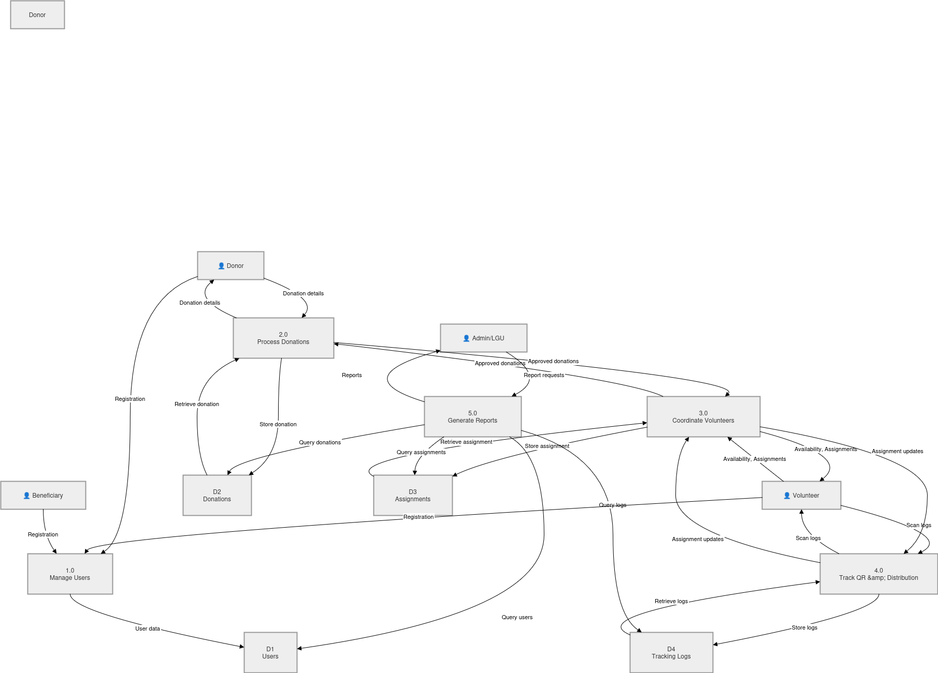
3.12.5 Non-Functional Requirements
The system must meet the non-functional requirements shown in Table 3.6.
Table 3.6: Non-Functional Requirements
Attribute | Requirement
Usability | System shall achieve a SUS score of at least 70
Performance | Pages shall load within 3 seconds on a 3G connection
Security | All passwords hashed; role-based access enforced
Reliability | System uptime of 99.5% during testing period
Portability | PWA must function on latest Chrome, Edge, and Safari mobile browsers

3.13 Design Phase
This phase translates the analysis outputs into a concrete blueprint for the system.
3.13.1 Interface Design
Low-fidelity wireframes were designed for the main modules, including the donor dashboard, donation posting form, volunteer assignment screen, QR scanning interface, and admin analytics page. Figure 3.5 shows representative wireframes.
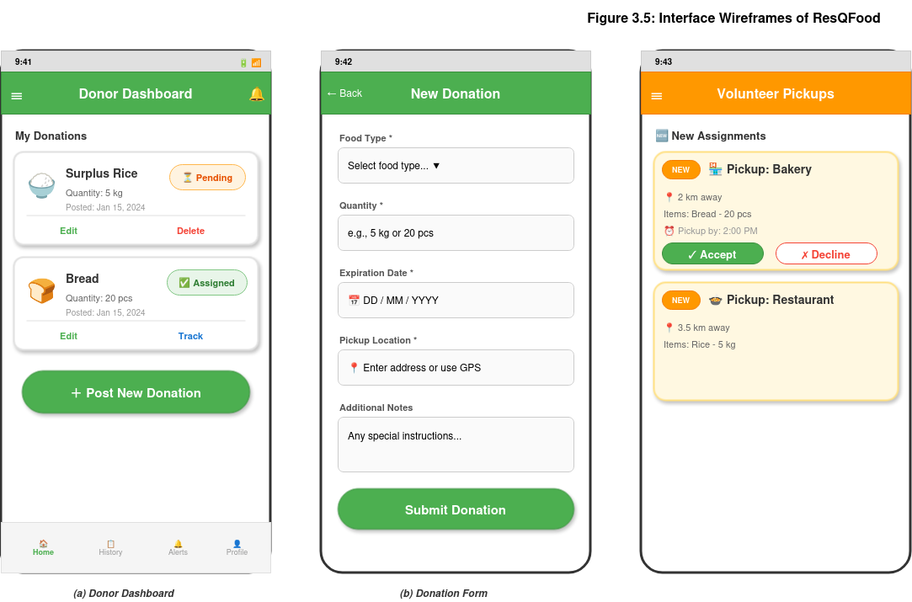
Figure 3.5

3.13.2 Database Design
A relational database was designed to store all system records. Figure 3.6 presents the Entity Relationship Diagram (ERD), and Table 3.7 provides a partial data dictionary.
ERD – Figure 3.6
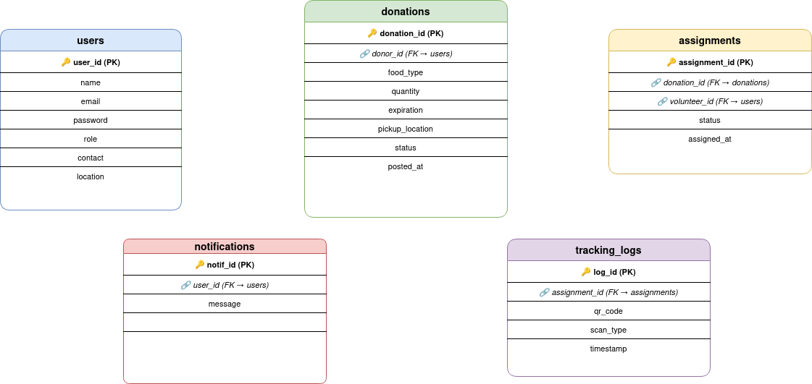
Table 3.7: Partial Data Dictionary for the “donations” Table

FIELD | DATA TYPE | CONSTRAINTS
donation_id | INT | PRIMARY KEY, AUTO_INCREMENT
donor_id | INT | FOREIGN KEY to users
food_type | VARCHAR(50) | NOT NULL
quantity | DECIMAL(5.2)
posted_at | DATETIME | DEFAULT CURRENT_ TIMESTAMP
Status | ENUM(‘pending’, ‘assigned’, ‘picked_up’, ‘delivered’)

3.13.3 Class Diagram
The system’s main classes and their relationships are modeled in the class diagram in
Figure 3.7.
Class Diagram – Figure 3.7

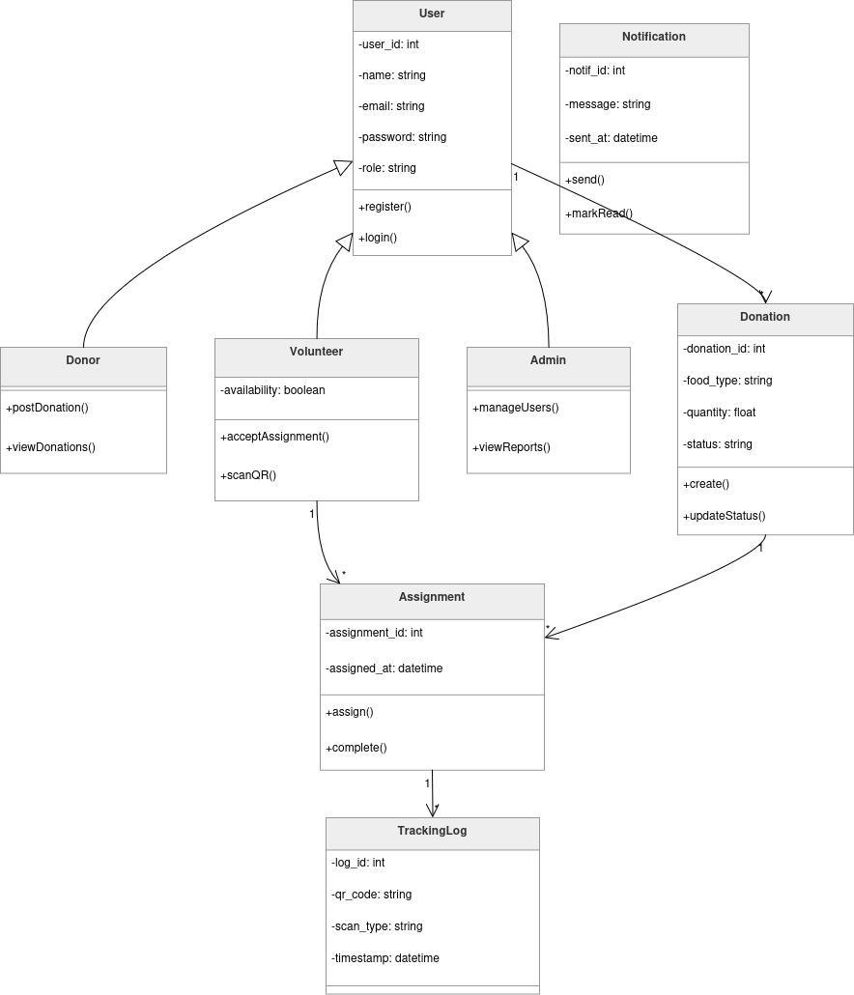

3.14 System Architecture

ResQFood follows a three-tier architecture consisting of a Presentation Tier, an
Application Tier, and a Data Tier, as illustrated in Figure 3.8.

- Presentation Tier: A Progressive Web Application built with HTML5, CSS3, and
JavaScript (or React.js). A service worker enables offline caching and push
notifications.
- Application Tier: A RESTful API built with Node.js and Express.js, handling
business logic, user authentication via JSON Web Tokens (JWT), notification
dispatching through Firebase Cloud Messaging, and QR code generation/validation
using a cryptographic hash.
- Data Tier: A MySQL relational database that stores user accounts, donation
records, volunteer assignments, and tracking logs. Data is accessed exclusively
through the API.

Three-tier architecture diagram – Figure 3.8
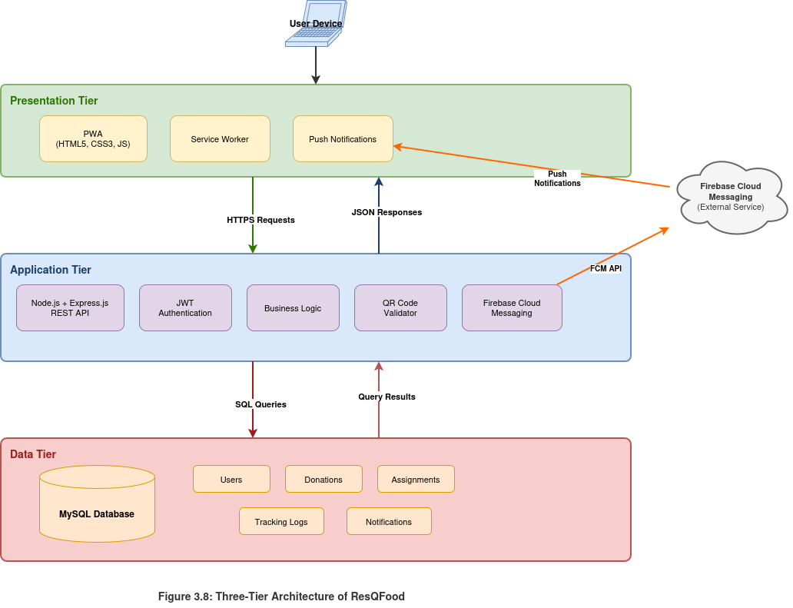

References

[1] Food and Agriculture Organization, Global Food Losses and Food Waste – Extent, Causes and Prevention. Rome, Italy: FAO, 2011.
[2] United Nations Environment Programme, Food Waste Index Report 2021. Nairobi, Kenya: UNEP, 2021.
[3] World Resources Institute, Reducing Food Loss and Waste: Setting a Global Action Agenda. Washington, DC, USA: WRI, 2019.
[4] Sharing Excess, “Food Rescue and Redistribution Programs,” 2023. [Online]. Available: https://www.sharingexcess.com
[5] B. Lipinski et al., Reducing Food Loss and Waste. Washington, DC, USA: World Resources Institute, 2013.
[6] A. Biørn-Hansen et al., “Progressive Web Apps: The possible web-native unifier,” WEBIST, 2017.
[7] S. Papargyropoulou et al., “The Food Waste Hierarchy,” Journal of Cleaner Production, 2014.
[8] United Nations, Sustainable Development Goals, 2015.
[9] V. Venkatesh et al., “User Acceptance of Information Technology: Toward a Unified View,” MIS Quarterly, vol. 27, no. 3, pp. 425–478, 2003.
[10] S. Gajendra et al., “Progressive Web Apps (PWA) vs Native Apps: A Comparative Study,” International Journal of Computer Applications, 2021.
[11] J. R. Gil-Garcia and T. A. Pardo, “E-government success factors: Mapping practical tools to theoretical foundations,” Government Information Quarterly, 2005.
[12] M. Jou et al., “Application, impacts, and challenges of the Internet of Things in digital systems,” Epsir Journal, 2026.

CHAPTER 3: RESEARCH METHODOLOGY

CHAPTER 2: REVIEW OF RELATED LITERATURE AND STUDIES

INTERNATIONAL

LOCAL

REVIEW OF RELATED STUDIES

Theoretical Background

Conceptual Framework

CHAPTER 3: RESEARCH METHODOLOGY

I. RESEARCH DESIGN

II. RESEARCH LOCALE

III. PARTICIPANTS

IV. RESEARCH INSTRUMENT

V. DATA GATHERING PROCEDURE

VI. DATA ANALYSIS

VII. RESEARCH VALIDITY

VIII. ETHICAL CONSIDERATION

REFERENCES:

